Revolutionizing Hydration: E ploring the Potential of Smart Water Fountains



# Introduction

Welcome to the world of **smart water fountains**! In this presentation, we will explore how these innovative fountains are revolutionizing **hydration**. Discover the potential of these intelligent devices to improve access to clean drinking water and promote healthy lifestyles. Get ready to dive into the future of hydration!

## The Need for Change

Current water fountains lack **smart features** and fail to meet modern expectations. Many are outdated, unhygienic, and inconvenient. By revolutionizing hydration through smart water fountains, we can address these shortcomings and provide a better drinking experience for everyone.

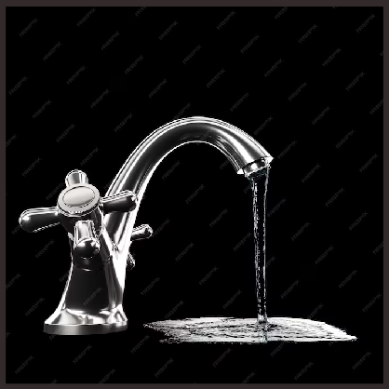

## Smart Water Fountain Features

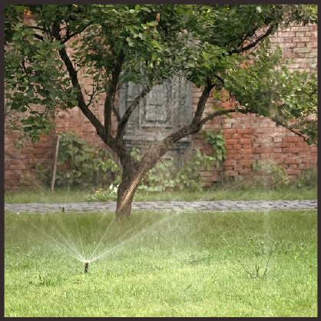Smart water fountains come packed with exciting features such as **real-time water quality monitoring**, **touchless operation**, **integrated hydration tracking**, and **customizable water preferences**. These

advancements ensure a safe, convenient, and personalized drinking experience for users.



# Promoting Sustainability

Smart water fountains play a crucial role in promoting **sustainability**. By encouraging the use of reusable bottles and reducing plastic waste, these fountains contribute to a greener environment. Additionally, they can be powered by **renewable energy sources** to minimize their carbon footprint.



Enhancing Hydration E perience



With smart water fountains, the hydration experience is taken to new heights. Users can enjoy **customizable water temperature**, **ﬂavor infusions**, and even **interactive games** while hydrating. These features make drinking water more exciting, encouraging people to stay hydrated throughout the day.

## Improving Accessibility

Smart water fountains are designed with **accessibility** in mind. They include features like **wheelchair accessibility**, **multilingual interfaces**, and **audio**

**instructions** to ensure that everyone can easily access clean drinking water. These inclusive designs promote equal opportunities for hydration.

## Data-Driven Insights

The data collected by smart water fountains provides valuable insights into **hydration patterns** and **usage trends**. Analyzing this data can help organizations and communities make informed

decisions to improve water infrastructure, optimize maintenance, and promote healthier habits.

Smart Water Fountain Implementation

Implementing smart water fountains requires collaboration between **technology companies**, **government agencies**, and **public institutions**. By

working together, we can ensure the widespread adoption of these innovative devices, creating a network of smart water fountains that beneﬁts communities worldwide.

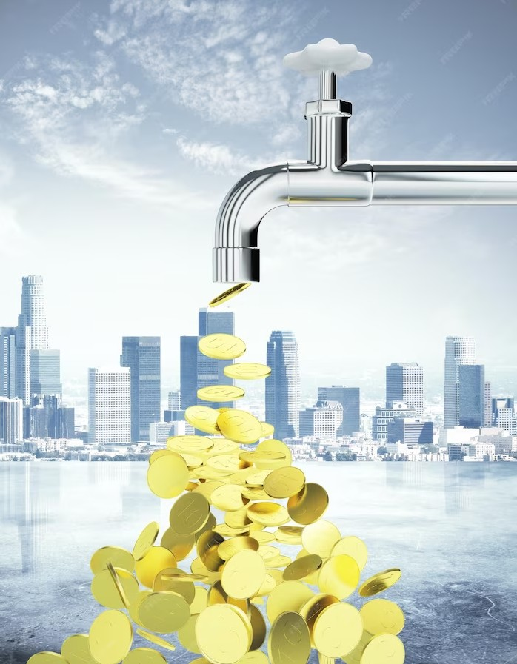

# Future Possibilities

The future of smart water fountains holds endless possibilities. With advancements in **artiﬁcial intelligence** and **Internet of Things**, we can expect even more intelligent features like **automatic bottle reﬁlls**, **personalized hydration reminders**, and **real-time water consumption data**.

Get ready for a future where staying hydrated is easier than ever!



## Conclusion

Smart water fountains have the power to revolutionize hydration by providing a safer, more convenient, and personalized drinking experience. With their sustainable practices and inclusive designs, these fountains promote a healthier lifestyle and contribute to a greener environment. Let's embrace the potential of smart water fountains and ensure access to clean drinking water for all.